C

Consumer Guide to Bird Window Strike Prevention
“ An Impressive Resource for Consumers”
Dr. Daniel Klem - Nation’s Leading Window Strike
Prepared by Jim Cubie – former Nader consumer advocate

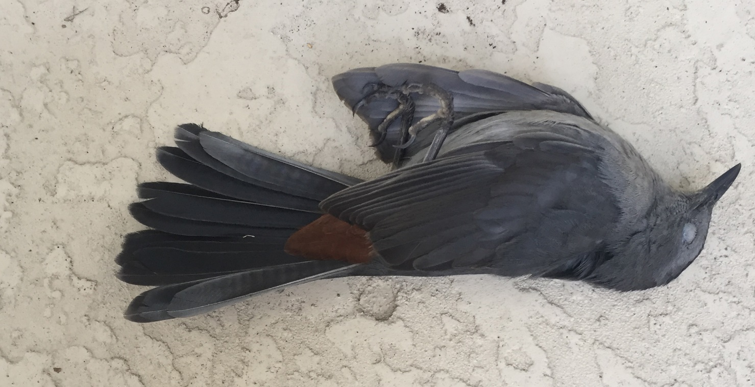
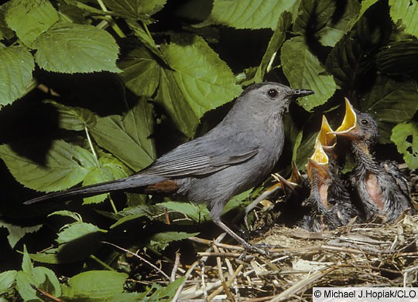
Catbird Killed Hitting Author’s Front Glass Door
Each Nest Promises New Life
Catbird killed hitting authors front glass storm door. One parent means half the chicks do not survive
You are here because you have decided to protect the birds in your yard from window collision deaths and are not sure what to do. There are so many “solutions” on the web – “It’s the wild west” as one observer noted. This guide describes which options work, their costs, photos and DIY directions for each. (All underlined text are links. Ctrl/click in Word; click only in PDF)

Quick Advice: If you are in a hurry, for information about what options I would recommend in different situations (cost, durability etc.) click here – Quick Advice

This guide was prepared by a retired attorney who worked for consumer advocate Ralph Nader and subsequently several environmental organizations. For the past 3 years he has led efforts in his bird club and community to convince people to install bird window protection. His sun room is set up as a display room. He has installed all of the commercial systems and has fabricated all of the DIY systems. The costs have been confirmed by the vendors.

Clubs are free to download this document for their members. When the American Bird Conservancy posts more approved systems on their site this guide will also be updated. An update will also compare the costs of the all the common window sizes.

Please address comments to jimcubie1@g*****.com. If you want the update, please email me.

Contents
Ctrl-Click of click on any underlined text in this document to go to that section.

- Basic Science
- Why Typical Install of Window Alert Does Not Work
- How Many Windows Should I Do?
- Two Basic Window Strike Prevention Strategies
- Threat Factor Ratings
- Commercial Systems Described
- DIY Options
- Cost Comparison of Principal Systems
- Factors to Consider In Choosing A Window Protection System
- Effect on Vision and Photos comparing installed systems
- Glass Doors
- Window Washing

basic Science

Dr. Daniel Klem, the leading window strike researcher explains:
Most often, we humans recognize that an opening in a human structure is covered by glass. Birds do not. Scientific studies have repeatedly confirmed that clear and reflective windows are invisible to birds. They are killed hitting these invisible barriers trying to reach habitat seen through or reflected on their surface. Only by uniformly covering a window with an effective strike-deterrent pattern will birds see and avoid it. Research also has repeatedly validated that effective strike-deterrent patterns consist of elements separated by 2” in horizontal rows or 4” in vertical columns.

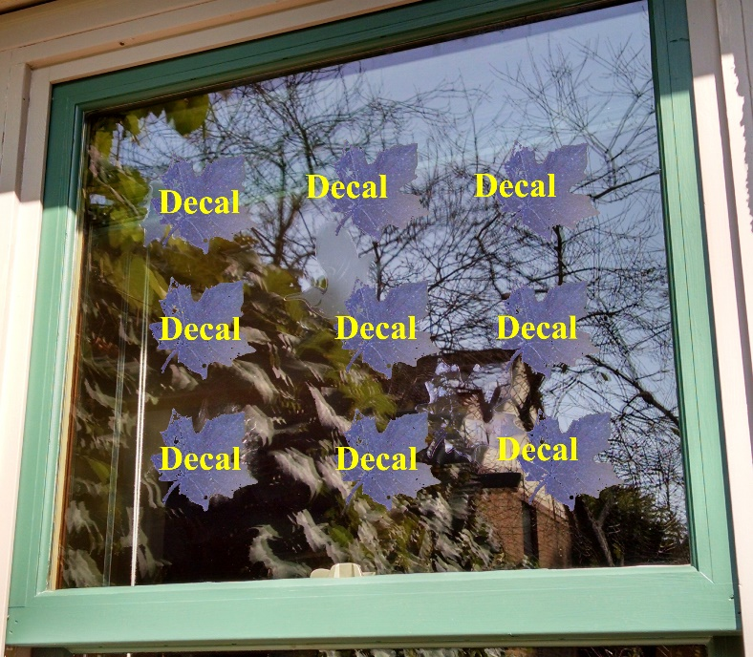
2. Why typical window alert installation does not work
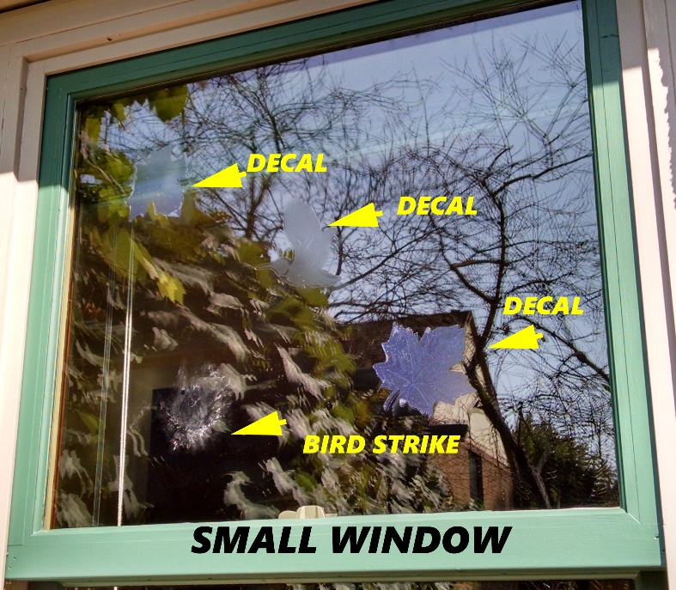
The basic science shows why the first reaction of many people, which is to “buy some decals to alert the birds that it is a window,” -- is a mistake.
On the left you can see 3 decals as they are often placed. Note that there is a bird strike in spite of the decals. Why? Because the bird saw enough space to fly around the decals. On the right enough decals are applied to meet the 4-inch spacing standard – now changed to 2 inches.
Several of the systems described and priced in this guide were developed to avoid the interference with the view illustrated in the right square above. See systemswithlessimpact
The American Bird Conservancy is now recommending that the 2” by 4” spacing standard be replaced by a 2” by 2” standard in order to protect hummingbirds which are uniquely vulnerable to window strikes. All the DIY systems can and should be fabricated with a 2” vertical spacing. Two inches is also the new Canadian standard.

3. How Many Windows Should I Do?
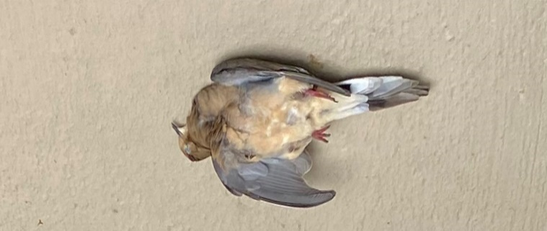
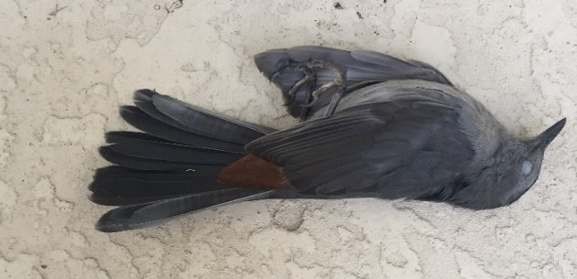
The answer is that any window or door in which you can see your reflection needs collision prevention. I assumed that when I had installed systems on my back sunroom facing the woods, that I had done the job. Since then I have had two window strike deaths. Their bird to the left below hit my front glass storm door. The bird to the right hit the sliding glass door on the side of my sun porch.

4. TWO BASIC WINDOW STRIKE PREVENTION STRATEGIES
There are two basic strategies for preventing deadly bird window collisions. The first is to prevent the bird from reaching the window. This includes the Bird Screen option described below and also netting. The second strategy is to make a bird “think” that the area he sees as a clear opening, is actually crossed with obstructions – i.e. branches – which are too close for him to fly through. These options were developed to limit the vision interference inherent in screens and netting. All the other options described below follow this strategy.
The prevention options are the most effective.

Do-it-yourself vs. commercially available systems.

There are good options for those who want to buy a system or who want to save costs by doing it themselves. The next section describes the commercial options followed by the DIY options. The commercial systems are described first because several of the DIY versions are clones of the commercial systems.

5. Threat factor Ratings

The American Bird Conservancy has developed a system for rating the effectiveness of window strike prevention systems based on testing. This guide only describes systems which meet their standards and will work as residential retrofits. Their system is described at https://abcbirds.org/glass-collisions/threat-factor-rating/ . On the cost comparison chart the “threat reduction” rating is listed. Like golf, the lower the number the better the system. If in the tests a system receives a rating of 1 it means that of the 80 birds tested, 79 avoided crashing because the system was in place. A rating of 25 means that of the 80 birds tested, 20 avoided crashing because the system was in place.

These ratings are very important because a system that appears cheap may not save many birds. Likewise a system that offers little vision interference, may not be as effective as another system.

6.Description of Commercial systems

Screens

Bird Screen Bird Screen is a system that uses fiberglass screen material supported by brackets that hold the screen out from the window. Suction cups hold the brackets to the glass window. With this system the homeowner has the bird protection benefit provided by screens, without needing commercial screen fabrication and installation. Purchase at https://www.birdscreen.com/ (No photo. It looks like a window with a screen.)

Commercial screens are also effective in reducing window strikes

Systems with Less Impact on Vision

The following commercial systems have been designed to achieve an acceptable level of window strike reduction while minimizing the interference with the vision out the window.
The commercial options are discussed first because most of the DIY systems are variations of these systems. See DIY options.

Acopian Bird Savers The Acopian BirdSavers system is a series of dark olive-green colored parachute cords hung vertically on the outside of the window four inches apart. As with all systems which place something to a window, some people will find any of these techniques either visually acceptable or visually unacceptable. According to Acopian, BirdSavers are unique in that most people find them “visually appealing and "elegant." They can be purchased or can be made very easily by the homeowner. You can buy them at https://www.birdsavers.com/acopian-birdsavers-for-rectangular-windows/ It is a very cost effective system because of its long life. There are two installation options; screw installation and Velcro tab installation. The Velcro tab system is the quickest and easiest system to install of all the window strike prevention options. Both are easy to install. Acopian generously provides do-it-yourself directions at their site. See also under Acopian BirdSavers DIY options. https://www.birdsavers.com/buildyourown.html
See photo at compare to clear window A

Bird Crash Preventer (Fishing Line System) The Bird Crash Preventer is a ready-to-hang "curtain" of fine nylon monofilament lines. Brackets and screws are included for self-installation. It is very well made in a limited set of sizes. Purchase at http://stores.santarosanational.com/ It has the advantage of being virtually invisible when you look out the window and is the popular among my club members. Compare to clear window. The delivery costs, which are significant, are included in cost comparison.

FeatherFriendly This is a series of very small squares (1/4”, 6mm) arrayed in a 2 inch by 2-inch pattern. The small squares adhere to a strip of clear carrier tape. After the carrier tape with small squares is installed, the carrier tape is removed. It uses 3M adhesives. It meets the 2” by 2” standard. Popular with my club members, especially for front glass doors. Purchase at https://www.featherfriendly.com/
Compare to clear window.

Solyx Bird Safety Film This product is a film is designed to deter birds from flying into reflective glass, thus suffering an injury or death. This film is easily applied to exterior glass, outside surfaces, and is made of a durable, crystal clear, outside weatherable, scratch resistant polyester film. This film has an expected outdoor life of seven years and is cleanly and easily removed and replaced if needed. It meets the two inch by two inch standard. https://www.decorativefilm.com/solyx-sx-bsfv-bird-safety-film-59-or-70-wide Photo compare to clear.

CollidEscape 2 by 2 This product is film on which a series of dots have been placed every two inches. It meets the two inch by two inch standard. Not tested by ABC, but it is included because it is so similar to the FeatherFriendly system. The film is offered in several widths starting at twelve inches. It is different from the FeatherFriendly residential product. The FeatherFriendly product is not a film covering the whole window. It is a strip of squares. Purchase at https://www.collidescape.org/online-store/2-x2-Repeating-Dot-Pattern-1-25-wide-rolls-16-p175135737

ABC Bird Tape Not available generally, but it is reported that there are some supplies still available on the web. It may be offered in the future.

Is the effect on vision of these systems acceptable? In this video two homeowners describe their experience with the Fishing line and Acopian BirdSavers systems see Bird window strike prevention: It worked for us.

7. Do It Yourself Options

- FeatherFriendly - Dot System
- Acopian Bird Savers –Parachute Cords
- Bird Crash Preventer Clone - Fishing Line System
- White Line System
- Netting and Screens

FeatherFriendly

The commercial product for homes is designed as a DIY install. Excellent directions come with the product. They are also at
https://store.featherfriendly.com/content/Feather%20Friendly%20-%20Installation%20Instructions.pdf

To line up the squares vertically: 1. Cut a series of strips a little longer than the glass is wide. 2. Cut each one at the edge of the first white square and line it up against the left window frame so that the squares are lined up vertically. 3. As you remove the carrier tape place the plastic squeegee on the square to prevent the tape from separating the white squares from the glass.

A clone of this product can be if you have a Cricut or similar paper cutting machine. Create the design so that ¼ inch squares are spaced two inches apart in each direction. Cut it using vinyl cabinet lining paper. Remove the backing and place on window. Burnish the vinyl. At this point there are two options. Remove the vinyl leaving only the ¼ squares by placing a pen on each square. The square will adhere to the window, leaving a pattern of ¼ inch squares spaced 2 inches apart. Since it must be applied to the exterior face of the window it is likely to wear out quickly.

Alternatively, make sure the ¼ holes are empty and then apply the vinyl sheet on the window. Take a permanent wide white marker designed for exterior use, and color in each square. Make sure you burnish around each hole to prevent ink seepage.

Acopian Bird Savers Paracord DIY Option

Directions for making the Acopian Bird Savers are at
https://www.birdsavers.com/buildyourown.html.
This is the simplest system to install. The materials are J-channel and paracord. If you buy the cord in small rolls it will need to be straightened. See the following video for straightening directions. https://www.youtube.com/watch?v=DPAnKe07nHw They do not straighten with light weights.
The Acopian BirdSavers can also be made as a retractable paracord system.

Alternative Fabrication Method. Acopian BirdSavers recommends fabricating the system with a knot at the top of each line. An alternative method some find quicker is to weave the paracord through the holes drilled and then cut to length at the end. Make sure that the bottom of the lines is below the level of the window so that the ends are not visible from the inside. It is not possible to cut them so they hang exactly the same length due to the curvature of the cord. (Acopian recommends that they be cut above the bottom of the window.)

White Lines on Window

A series of vertical white lines on a window, drawn 2 inches apart, prevents many bird strikes. See the following YouTube video for application instructions. https://www.youtube.com/watch?v=UC9xQkUtQ98 Pens that write on glass are available online or at hobby stores. Make sure the pens are “oil based.” Making the lines straight and evenly spaced is a challenge. Be sure to use a waterproof pen. The lines could also be made with tape.

Bird Crash Preventers Fishing Line System

The Bird Crash Preventer (Santa Rosa) site does not offer DIY directions, but I have spoken to the owners and they have no problem with DIY clones. Here are two options.

- A DIY version which matches the basic specifications of the commercial model, in terms of spacing between the lines, distance from the window and monofilament diameter, is available. Ctrl-click or click monoverticaldiy for specific directions.
- A very clever neighbor has developed a technique that you can use to cover an area as large as a whole sun room in an hour. See https://www.youtube.com/watch?v=m5jf28Xwob0&t=40s Caution – as he installs it, it is not clear whether it meets the “5 inches from the window glass standard.” It must.

Monofilament Maintenance Since monofilament line stretches, it is usually necessary to retighten the line after a few weeks. The commercial system retightens by rotating the bottom cross piece. Tightening of DIY system is described below. Monofilament line has a very long life (disposing of it is a major conservation problem at boat landings.) It will get brittle. Braided fishing line should not get brittle. There are affordable options for braided line on eBay.

netting and screens
Garden netting is sold at big box and hardware stores for temporary protection of a garden. There are also “heavy duty” versions. These typically have some form of coating to prevent UV damage. I am assuming that a consumer who installs a system wants it to last for many years. Thus in the price comparison chart above I have only included products marketed as “heavy duty.” There are many suppliers of bird netting with prices varying from about $20 to $150 for a 12-foot window.

It should be mounted away from the window and taut enough to prevent contact by a flying bird. I would also suggest that an escape area be left open at the top of the window. Most frightened birds escape by flying upward.

Netting is simple to install. Most homes have an overhang (soffit) to which it may be applied with staples, or over screws. Option one below is a better option, even though it is more expensive, because of the strength and durability of the plant hangers.

Option one —Netting over plant hangers. Plant hangers are inexpensive ($3.88 each Lowes Style Selection 7-in Black Steel Plant Hooks LWP013) Mount the hooks at the top and bottom of the window and fit the netting into the hooks. Draw taut. Wide windows will probably need more than 2 hooks at the top and the bottom in order to get the netting taut. The approximate cost of this option for a 12-foot window space is about $62.

Option two — Use café rods and electrical conduit. Place café rod brackets above and below the window. Metal electrical conduit (1/2”) designed for exterior use costs only about $3 for ten feet. Stretch the netting between the upper and lower rods so that it is taut. One option is to attach the netting to the conduit with poly clips. They grasp the netting and have a place to connect to a support. The cost is $25 for 25. Another option for making the netting taut is to attach the netting to the conduit with cable ties. A third option is to cut the netting about the height of the window, secure it to the conduit (cable ties, glue, etc.) place the conduit in the upper café brackets, roll the bottom until the netting is taut, and tighten the screw in the lower café rod holders. Cable ties will degrade over time. The overall cost of this option, is about $ 95 for a 12-foot window. (not using polyclips.)
Polyclips can be found at https://www.nixalite.com/product/polyclips?gclid=CjwKCAiA2O39BRBjEiwApB2Ikj45CVx6s0YdoAhFeLqCQTFwqF8jaeV4aX2c5Nea-fRjl4s_ZTlNChoCFOAQAvD_BwE

Option three– Fabricate netting screens. DIY screen kits are widely available. These kits come in sizes up to 48”. The kits include directions. Instead of placing screen material in the screen frame, place the netting in the channel where the screen material is normally in placed and use the roller tool to install it. Plant hangers or café rod brackets may work to hold the screens – tying with cable ties if necessary. In this case the brackets would face up on the bottom and down on the top. The approximate cost of this option for a 12-foot window space is $ 93.

4. Factors in Choosing a Window Bird Protection System

Ctrl/click or click to follow
- Does it work?
- What Does It Cost? – initial and long term
- What Is Its Effect of Vision out the Window? See visionoutthewindow
- How Hard Is It to Install?
- Will It Work on a Door?
- Window washing

dOES IT WORK?
Only systems tested by the American Bird Conservancy or very close clones are recommended here. Https://abcbirds.org/get-involved/bird-smart-glass/ (Netting has not been recommended by ABC. It is recommended by Cornell Lab.) Do not believe a vendor or neighbor who claims “I installed x and I have not had a strike.” Window collisions are infrequent and a person may not notice the strikes at all if he is not at home in the room where the collision occurred. Predators remove the dead birds. Likewise a guarantee to “replace the product” if you have a strike does not bring the bird back to life.

what does it cost
Here there are two considerations, initial and long-term costs. The initial costs are found at the Cost Comparison Chart.

Life Cycle Costs —In terms of life cycle costs none of the systems has a track record beyond 12 years. Judgements have to be made.

In deciding what product to buy a key question is what it will cost over the time you expect to be in the residence. If you expect to be in the residence 20 years, and you buy a product that has a useful life of 5 years you will have to buy and install the system 4 times. Thus, a system that costs $8 (white lines) will actually cost $32. However, if it is applied every 5 years it is actually more expensive than two of the more permanent DIY options. One also has to consider the time that will be spent reinstalling a short-lived system.

I have installed all of these systems, and have learned about their vulnerabilities over a three-year period. I would classify the options in this way:

Very Long Useful Life

Acopian Bird Savers Screw Installation
Once installed it is impervious to weather and withstands strong wind very well. The tape and Velcro option has a much shorter life than installing it with screws because of the limited life of adhesives.

High Quality Netting has a very long useful life, though flying debris may damage it.

Medium Useful Life

Systems Mounted Away from the Window
Fragility Concerns – Mounted systems are more fragile.
Bird Crash Preventers – (fishing line system) This system has a very long life but it can be damaged by windblown debris. Fishing line has a tendency to tangle. If made with braided line it should last a very long time. Since fishing line stretches the DIY version has to be adjusted after the first month.
Bird Screen- (screen mounted system) The screen itself will have a very long life, but the long-term reliability of suction cup mounts is unknown. Suction cups have loosened over time. It will also be damaged by flying debris.

Vendor estimates of useful life
- Acopian BirdSavers Tape and Velcro -- five years
- Bird Screen -- ten years In my experience the suction cups will loosen after three years.
- Acopian Screw installation – 20+ years

Externally applied decals and films. These products are applied on the outside surface of the window. They will be degraded by weather and window washing. Note – systems must be on the outside of the windows to be effective. Applying a few decals on the inside of a window has no bird safety value.
ABC tested and approved systems include the following - with vendor’s estimate of useful life
- FeatherFriendly --12 years
- Solyx Bird Safe Film 5-7
- CollidEscape 2 by 2 (not tested and approved by ABC but included because it appears to be an exact clone of FeatherFriendly.
The useful life of a white line system drawn with water resistant ink is unknown but certainly shorter than any of the above option.

Effect on vision out the window

For many this is a key consideration. Screens, netting and numerous decals interfere most with vision out the window. In the section Systems with Less Impact on Vision a number of commercial and DIY systems are described, including comparison photos.

how hard is it to INSTALL?

I have installed all of these systems. They all can be installed by anyone who is reasonable handy. The systems that require the attachment to the residence can face difficulties depending on how the residence is constructed and the composition of the trim and siding - wood, stucco, vinyl, Hardie Plank, brick -- noted as “attachment considerations” below.

Acopian BirdSavers Paracord Velcro – very quick and easy, no tools. https://www.youtube.com/watch?v=ftsRPHIN0zY

Acopian BirdSavers Paracord Screws and clamps – simple, attachment considerations. https://www.youtube.com/watch?v=CrZrP50gGNk

Bird Screen - simple to install, cutting and fitting required. Window must be very clean. https://birdscreen.com/

Bird Crash Preventer Fishing Line System – Simple to install, but attachment considerations. http://stores.santarosanational.com/

White Line System – difficult to apply lines straight and evenly spaced. https://youtu.be/UC9xQkUtQ98

Fishing Line DIY – easy to install, attachment considerations. https://www.youtube.com/watch?v=m5jf28Xwob0&t=46s

FeatherFriendly – Simple, no tools needed, window needs to be very clean, care must be taken to line up squares. https://youtu.be/5mg4N2G_Nhg

Solyx Bird Safety Film- window must be very clean, care must be taken to avoid creasing.
https://www.decorativefilm.com/solyx-sx-bsfv-bird-safety-film-59-or-70-wide

8. Cost Comparison

The tables below compare the costs of both commercial and DIY Systems. A large standard window size of 12’ wide by 54” high is used to compare them. The cost of different size windows can be estimated by dividing or multiplying. Bear in mind that what appears to be cheaper may be more expensive depending on how long you expect to be in your home. (See life cycle costs) Note that these estimates include delivery costs, equalized to Kansas City, Missouri. The delivery cost of some systems can significantly affect their overall costs. All of these costs have been checked with the vendors. I have generated the DIY costs based on my experience fabricating and installing them. The difficulty of installation influences the cost if you use a handyman. The difficultly of installing the DIY version is reflected in the handyman cost in the cost comparison table.

Commercial Products | Base Cost | Base cost plus handyman hours - $40/hr. | Threat Factor Rating
AcopianBirdsavers Screw Install | $82.00 | $122.00 | 5 | https://www.birdsavers.com/acopian-birdsavers-for-rectangular-windows/
AcopianBirdsavers Velcro Install | $82.00 | $102.00 | 5 | https://www.birdsavers.com/acopian-birdsavers-for-rectangular-windows/
Bird Screen | $121.40 | $161.40 | 1 | https://birdscreen.com/
Bird Crash Preventer | $123.21 | $163.21 | 21 | http://stores.santarosanational.com/
Feather friendly | $69.00 | $129.00 | 23 | https://store.featherfriendly.com/feather-friendly-solution-for-do-it-yourself-residential-applications/
Solyx Bird Safety Film | $369.12 | $429.12 | 10 | https://www.decorativefilm.com/solyx-sx-bsfv-bird-safety-film-59-or-70-wide

DIY Options | Cost for 12 feet fabrication and installation | Threat factor Rating
Acopian Birdsavers DIY | $35.33 | 5 | https://www.birdsavers.com/make-your-own/
Fishing Line Home made | $28.30 | 21 | fislinediy
Feather Friendly Self Install | $69.00 | 21 | https://store.featherfriendly.com/feather-friendly-solution-for-do-it-yourself-residential-applications/
2 by 2 Dot DIY | $30.00 | 23 | fislinediy
White Line Option | $8.00 | 25 | https://www.youtube.com/watch?v=UC9xQkUtQ98
Screens plain | $92.85 | 1
Screens with netting | $93.46 | 5 | nettingdiy This is not an ABC rating
Netting- plant hooks | $62.04 | 5 | nettingdiy This is not an ABC rating
Netting between conduit | $95.84 | 5 | nettingdiy This is not an ABC rating

9.eFFECT ON VISION OUT THE WINDOW

Below are photos below comparing the Acopian BirdSavers, (paracord), and the Bird Crash Preventer (monofilament line option), FeatherFriendly, Solyx and garden netting to clear and/or screened windows. The white line system is not shown. The white line systems can be can be seen at https://youtu.be/UC9xQkUtQ98 .

How do people react to having anything on the outside of their windows?

In this video two neighbors https://www.youtube.com/watch?v=fZS5QVSJkCw&t=13s describe the effect on vision out the window of the Fishing Line system and the Acopian BirdSavers paracord DIY system.

Photos Begin Next Page

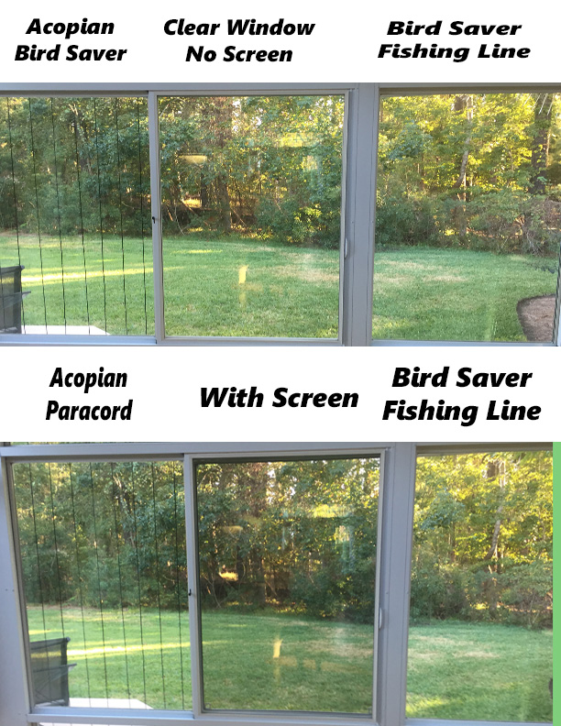
Acopian BirdSaver and Bird Crash Preventer Fishing Line Systems Compared to Clear Window

FeatherFriendly Photo Comparison In each case the upper half has the FeatherFriendly system and the lower half does not. There is little visual interference.

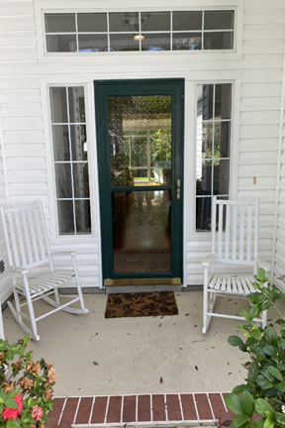
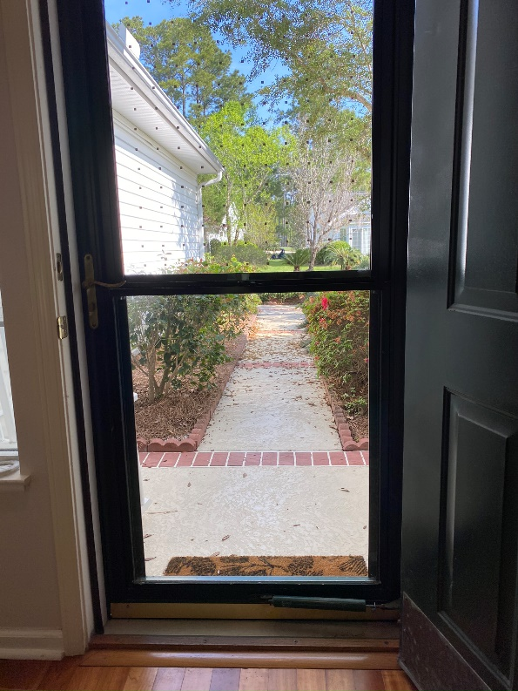

Solyx Compared to clear

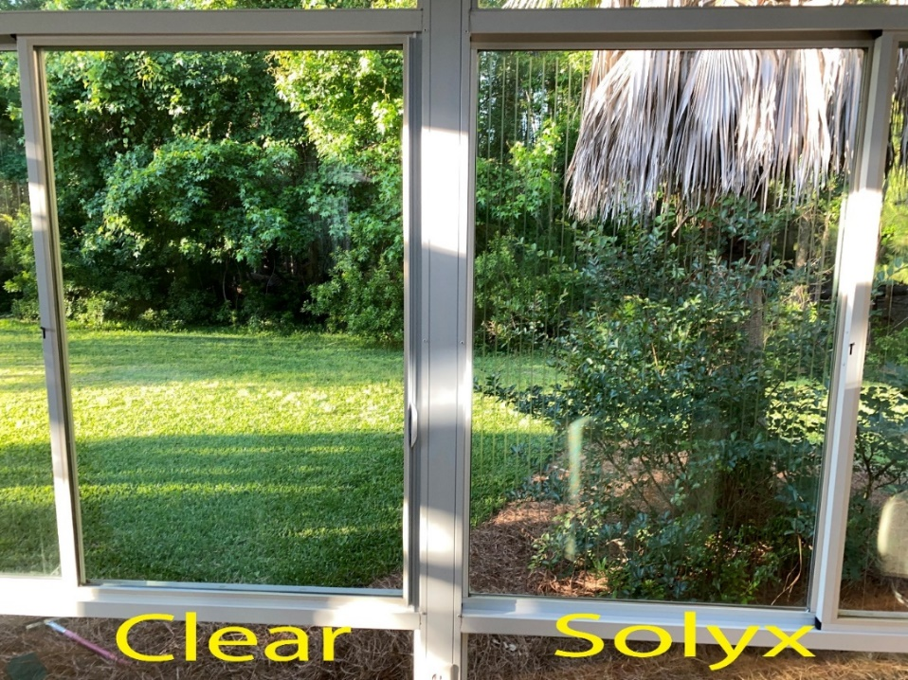
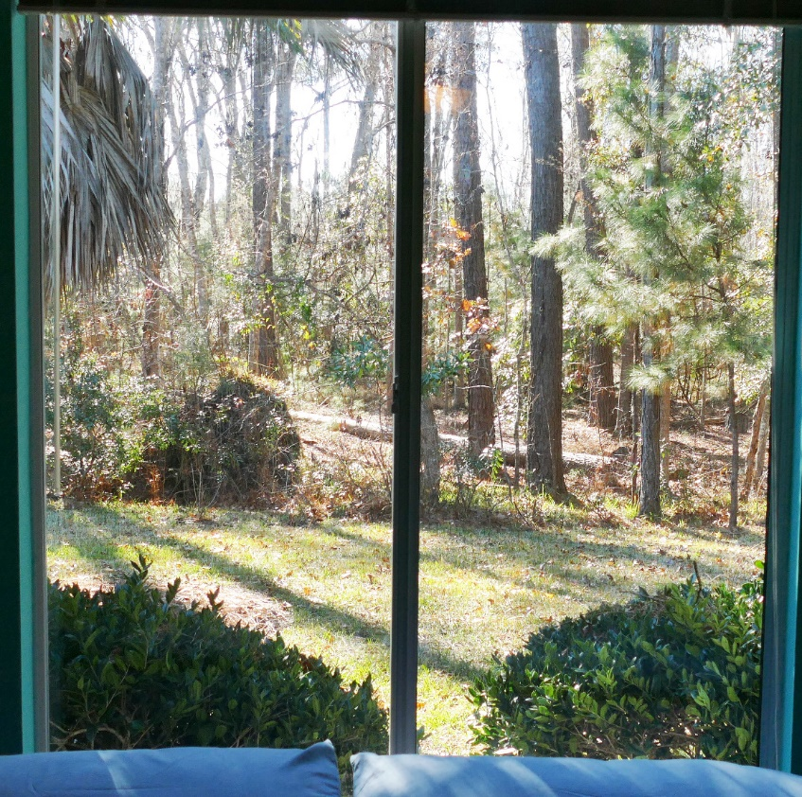
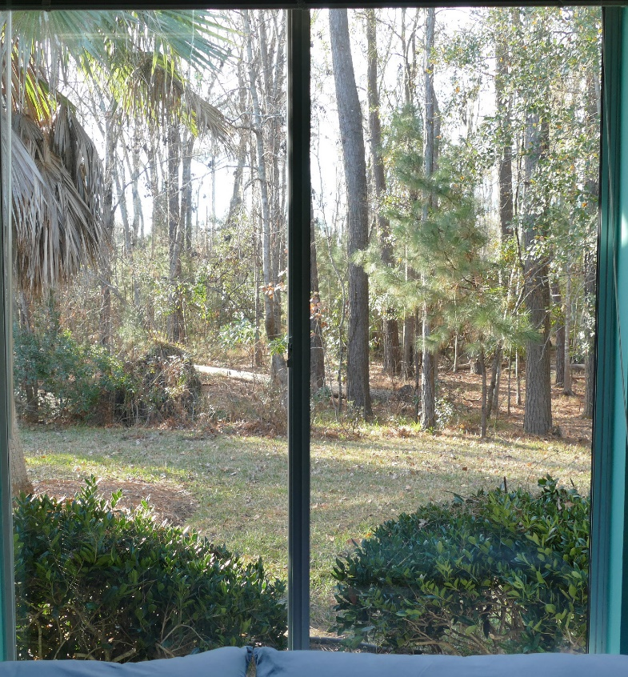

Clear Window

Window With Netting

Retractable acopian birdsavers

If you would like the option of retractable paracord style bird savers, it is simple to do, but more costly than a basic Acopian BirdSavers design using J-channel.
- Obtain a vertical blind head rail and cut it to the size of the width of your window. Both Lowes and Home Depot sell vertical blind head rails without the slats. They will cut it to size. You can also advertise on your community’s Facebook page for people that are throwing out vertical blinds. The cost of the commercial head rails is $20-$35, with sizes up to 80 inches. Head rails as long as 15 feet can be ordered off the web.
- Cut 1/8-inch paracord the height of the window, leaving room for a knot on one end. The paracord is sold by the “foot” off rolls at Home Depot or Lowes. If you buy the cord wrapped up in small packages it will have to be straightened. (Small weights will not do it.) To straighten go to https://www.youtube.com/watch?v=DPAnKe07nHw
- Much cheaper long rolls are available on line. You can always use extra paracord.
- Knot one end and insert it in clasp where the blind normally is inserted. It will stay. Repeat across headrail.

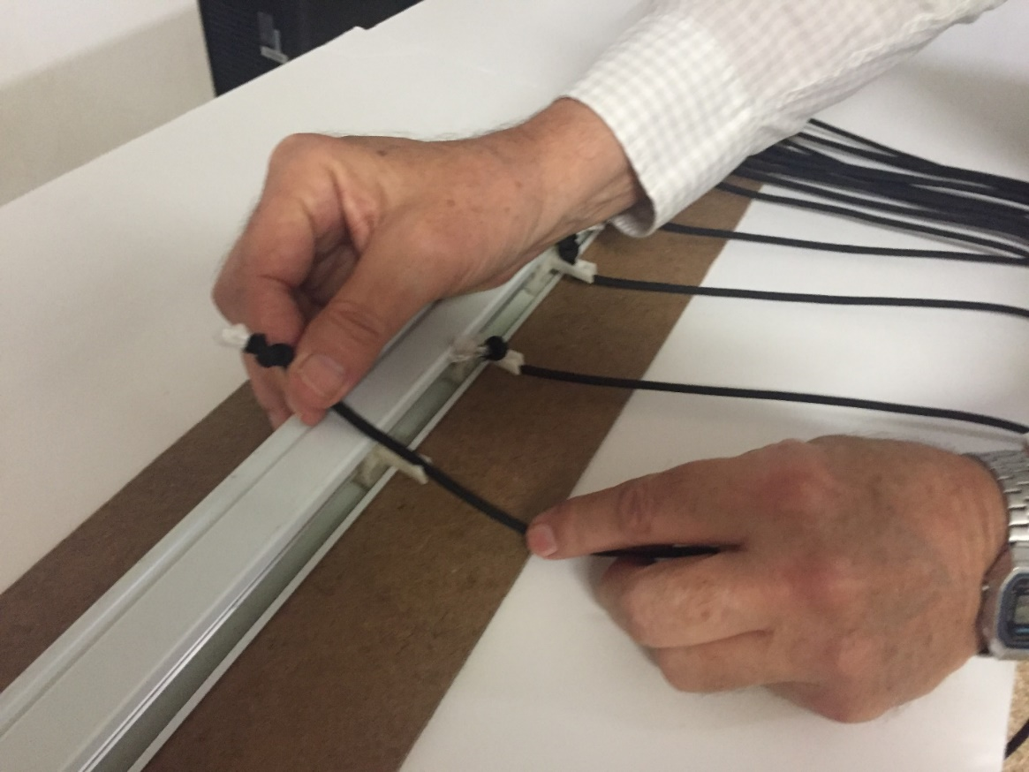

Install on the outside of the window with the attachment mechanisms supplied with the headrail. Here’s what they look like installed.

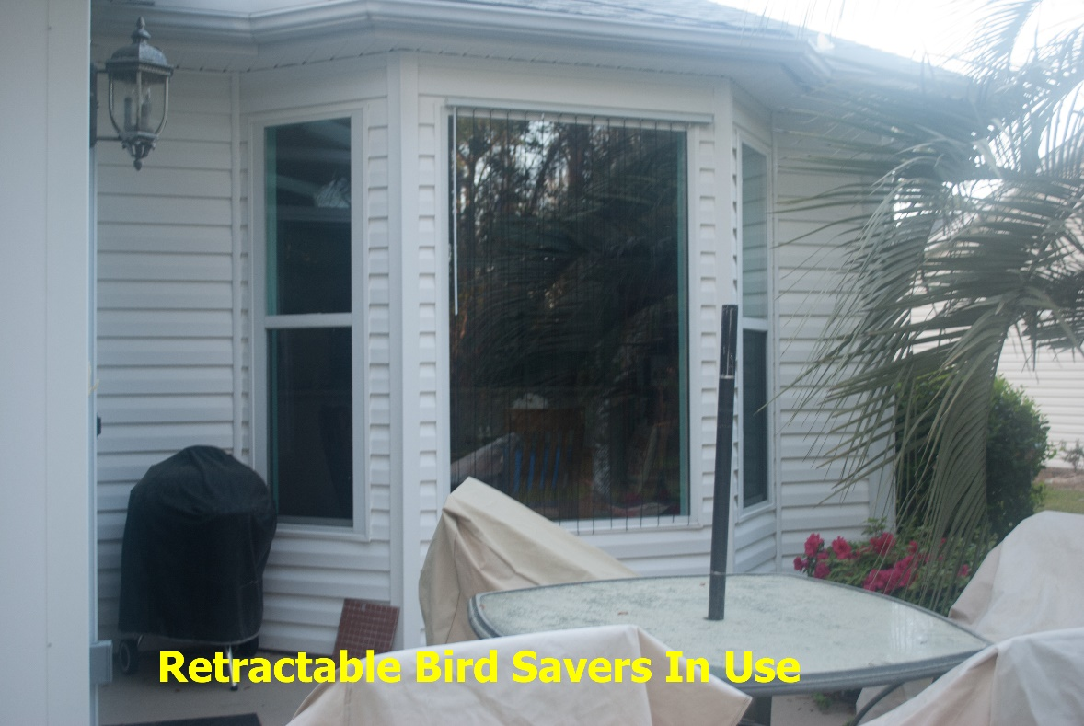
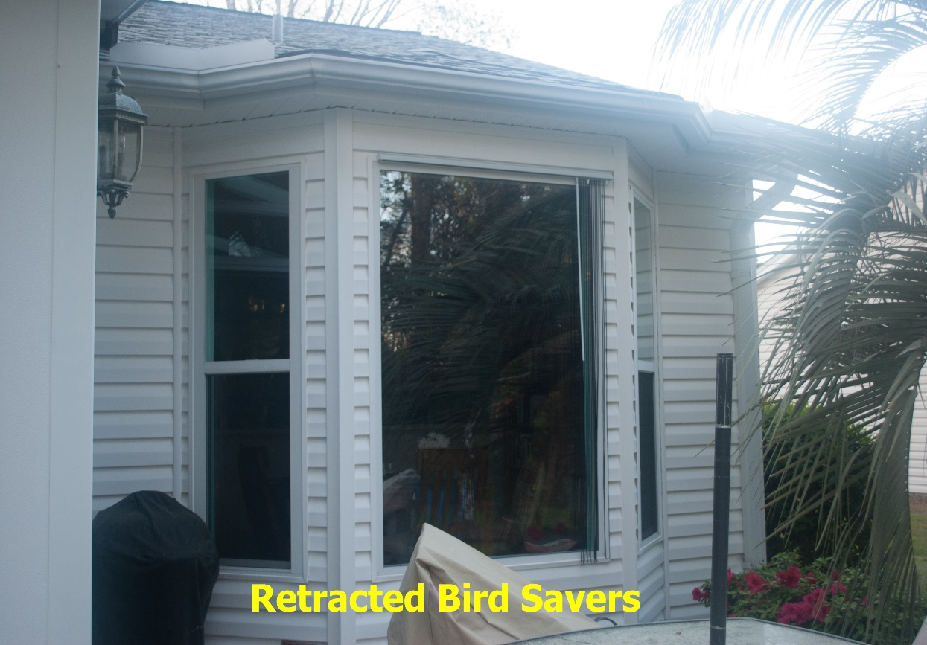

Monofilament Line DIY Option

In this section I will describe how to make DIY fishing line bird crash preventers. There are two options: horizontal and vertical. The vertical system has been tested and approved by ABC, the horizontal version has not. Since it meets the 2 inch standard it is included here.

Horizontal – and entire sunroom can be protected in a half hour for about $30. Make sure that the line is at least 5 inches off the window – the approved spacing. See this video https://www.youtube.com/watch?v=m5jf28Xwob0&t=54s

Vertical —This is the most complicated of the DIY options, but interferes least with vision. It takes a long time to describe, but it is not real complicated. The DIY cost is $20 per 12 feet.

Materials you need to buy:
- Twenty-pound fishing line –at Walmart
- J-channel - This a long (12.5 ft.) piece of vinyl plastic that is used in vinyl siding installations. It is readily available at Lowes and Home depot. It costs less than $5/piece. It is available in ½ and 5/8-inch dimensions. Make sure you get the ½ inch size so it will fit in the café rod brackets. They will cut it or you can cut it with a utility knife or tin snips.
- Bracket material – The J-channel through which the fishing line is woven is supported by brackets at the top and bottom. You will need a bracket every 4-5 feet. There are two options. The easiest option is drapery brackets which are sold at Walmart and big box stores.

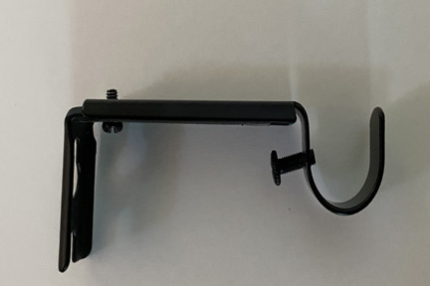

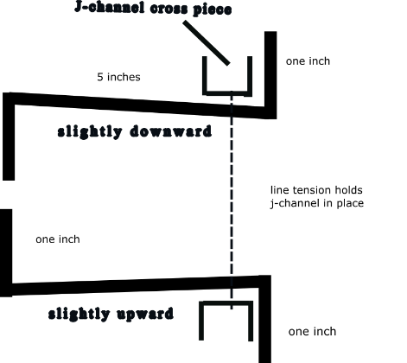
- The other option is to make them yourself from 1/8 stock aluminum from the big box store, as diagrammed below.
- Drapery brackets should be listed as ¾ to 1 inch, so the ½ inch j-channel (not 5/8 inch) fits in them. The home depot brand is Home Decorations. They are called “Orb Metal Café Rod ¾ inch.” A pair costs about $5. Only the adjustable size extends to 5 inches. They must be primed and pained to prevent rust.

- ¼ inch drive gutter screws. (Located with gutter material)

Making the DIY Fishing Line System
- It is essential that the brackets stand off of the window frame 5”. I have checked this with the scientist at the American Bird Conservancy.
- If you use the Café Rod brackets extend them as far as possible –

Preparing the J channel
- Cut off the slotted strip on the top of the j-channel. It is not needed.
- Measure the width of the window to be covered and make two pieces of that length.
  - Drill a ¼ inch hole (+ or -) every three inches. A jig helps if you are making several. Remember to locate the holes in the bottom and top piece of J-channel so that when you flip one over, they match. They must match or the line will not hang straight.
  - Use a piece of the j-channel you have cut off to make a “needle” which you will use to thread the fishing line through the holes in the J- channel.
- Install the brackets. Install the brackets every 4-5 feet along the top and bottom of the window. The attachment you use will depend on what your window frame or siding is made of. The entire system is so light you can drill the bracket screws in vinyl window trim if it is stable.
- Place a piece of J channel on the top bracket, with the bracket opening pointed up and temporarily install the other facing down under the bottom bracket. Secure the lower channel piece with cable ties while you weave the fishing line.
Installing the fishing line
  - Spray lubricant on the holes of the J channel where it will not be visible. The lubricant makes it easier to run the line through the holes.
  - Take the “needle” you made as noted above and tie to it the end of the fishing line.
  - Start to weave from the left side from the first bottom hole through the first top hole and back down – until you have gone all the way across. Just let the line feed off the bobbin.
  - You will find that as you proceed you cannot just drag the line through the holes. You will have to pull up and down on the lines to give enough slack so that you can continue to feed the line. This is much easier with 2 people.
  - When you have completed the weaving leave two feet extra on the right side.
  - Drill in one of the gutter screws partially on the bottom piece of J-channel on the left side (where you started) and wrap the fishing line around the screw and few times and tighten it. You might want to add a little super glue. This is much easier than trying to tie it off.
  - Also partially drill another screw into the J-channel at the right end.
  - Now moving from left to right gradually tighten the line by pulling on alternate strands so that there is enough tension on the line that when the cable ties are cut off of the bottom piece of J-channel it does not fall. Do not over tighten. You want it tight, but loose enough so that if you have to take it down to wash the windows you can remove the bottom J-channel. The line will stretch and the aluminum bracket will flex.
  - When it is taut, wrap the line around the screw on the right side as you did on the left. I leave about a foot extra temporarily in case I need to tighten it after a month or so, which you usually need to do. If you run out of fishing line you should have bought a bigger spool – but it can be tied (blood knot for fly fishermen) and surgeons knot for the rest of us. The knot will be nearly invisible. You are done.

- Make sure that when you take it down that you roll it up carefully so that the lines do not cross. Fishing line likes to tangle. Do not take it down as a whole and lay it on the grass. It will get tangled up.

10. glass doors
Glass doors, like all glass surfaces are dangerous to birds. The catbird below was killed at my front glass door and the mourning dove at right at a sliding glass door on the side of my sunroom.
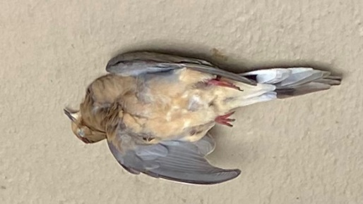
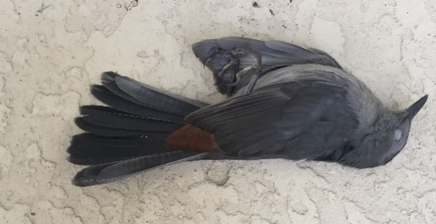
There are five options for doors– white lines, FeatherFriendly, Bird Screen (see special directions at birdscreen.com), CollidEscape 2 by 2, the standard Acopian BirdSavers type system and retractable Acopian BirdSavers. The FeatherFriendly, CollidEscape 2 by 2, and the white line system will not affect the movement of the door. The Acopian BirdSavers system of paracords can easily be spread aside for entry/exit. The retractable paracord (DIY Directions) system does not interfere with entry/exit. They also will not be visible when closed. The paracord can be retracted so they are not visible from the inside.

11.Window Washing

All the systems accommodate window washing. Products such as Windex Outdoor and Zepp Outdoor can be sprayed without removing any of the systems. They are designed to both wash and rinse without any need for scrubbing or a squeegee. Both the Acopian Bird Savers and the Bird Crash Preventer Fishing Line system also accommodate “scrubbing and squeegee” window washing. In the case of the Acopian Bird Savers, paracords are simply held aside during washing. For the Bird Crash Preventer fishing line system, the bottom cross piece can come out below the brackets and held overhead while the window is cleaned. See demo at https://youtu.be/Ji-iDmRdJNc FeatherFriendly attests that its system will accommodate “scrubbing and squeegee” window washing as long as abrasives are not used.

QUICK ADVICE

Here is my quick advice based on three years of experience installing all the systems and listening to the likes and dislikes of my neighbors when they have visited my sunroom where all of these systems are on display. All are installed on the outside of the window so inevitably affect your view. Keep in mind that attractiveness is subjective. See photo gallery to compare all options.

Ctrl/click of click on links

All these options meet the American Bird Conservancy standard. Only the netting and the bird screen option are 95+ effective. All the others are less effective in stopping strikes but have less impact on vision out the window.

Do Not Buy - Window Alert decals - as normally applied are ineffective.

Most Effective — BirdScreen https://birdscreen.com/or netting DIY system

Cheapest -- white line system, but hard to install neatly

Cheapest “Not White Line “Option Acopian BirdSavers or DIY monofilament line clone

Quickest And Easiest To Install - Acopian Velcro and Acopian BirdSavers clone and Netting DIY

Least Effect On Vision Out The Window - Bird Crash Preventer and DIY clone

Lasts The Longest - Acopian Screw installation and DIY clone

Best For Door - FeatherFriendly, DIY clone or Acopian BirdSavers DIY retractable

Not Visible To Visitors - Acopian BirdSavers clone retractable option

If You Are Not Handy At All — FeatherFriendly

Return to top of the document

